**CONTENT**

|  |  |  |
| --- | --- | --- |
| **S.No.** | **CONTENT** | **PAGE No.** |
| 1. | Abstract | 2 |
| 2. | Project Overview | 3 |
| 3. | System Design | 4 |
| 4. | System Flowchart | 5 |
| 5. | Input Design | 8 |
| 6. | Output Design | 9 |
| 7. | Menu Level Description | 10 |
| 8. | Process Specification | 11 |
| 9. | Screen Layouts | 14 |
| 10. | Conclusion | 16 |
| 11. | Bibliography | 17 |

**ABSTRACT**

# The Blood Bank Donor Management System is a lightweight, web-based solution designed to streamline the process of managing blood donor information efficiently and securely. With the increasing demand for rapid blood donation responses and the growing number of potential donors, there is a pressing need for a system that not only simplifies donor registration but also enables quick access to critical donor data during emergencies.

# This project aims to digitize traditional paper-based donor records through a user-friendly interface built using HTML, CSS, and JavaScript. By leveraging the browser’s local Storage feature, the system stores donor information—including name, age, blood group, contact number, Aadhar number, address, and last donation date—without the need for a backend server or database. This makes the solution highly suitable for small-scale blood donation camps, clinics, and mobile medical units where internet connectivity or infrastructure might be limited.

# The system allows new donor entries through a structured registration form and displays registered donors in a card-style layout with built-in search and filtering functionalities. This facilitates real-time lookup based on name or blood group, which is particularly useful during critical situations were finding the right donor quickly can save lives.

# Furthermore, the software emphasizes data integrity, validation, and usability, ensuring that only complete and accurate records are stored. The modularity and simplicity of the system make it an ideal educational and community-use project, demonstrating how modern web technologies can be applied to solve real-world problems in the healthcare domain.

# INTRODUCTION

### PROJECT OVERVIEW

The project entitled Blood Bank Donor Management System is a web-based, user-friendly solution developed to streamline and digitize the essential operations involved in managing blood donor information. This system is specifically designed to register, store, and retrieve blood donor data efficiently, with the aim of supporting faster and more reliable blood donation services, especially in emergency situations and blood donation drives.

The system facilitates the input of critical donor information such as name, age, Aadhar number, blood group, mobile number, residential address, and the date of the last donation. Using a structured and intuitive registration form, users can securely enter donor details, which are then stored locally in the browser using the JavaScript Local Storage API. This eliminates the dependency on internet connectivity or a centralized database server, making the solution highly portable and suitable for mobile health units, small clinics, or community blood banks.

Access to the system is categorized into two main components: the Donor Registration Interface and the Donor Listing Interface. The registration form allows for data input with validation mechanisms to ensure completeness and accuracy, while the listing page displays all stored donor records in a well-organized card format. Additionally, a built-in search functionality allows for real-time filtering based on donor name or blood group, aiding healthcare professionals and volunteers in quickly locating potential donors during urgent requirements.

The application follows a logical and minimalistic workflow that simplifies user interaction without compromising data quality. The modular design ensures ease of navigation and scalability for future enhancements, such as integration with cloud databases or hospital networks. By reducing manual data entry errors and enabling rapid data access, the system enhances operational readiness and supports life-saving decision-making.

## 2. SYSTEM DESIGN

### 2.1 INTRODUCTION

System design is the process of defining the architecture, components, modules, interfaces, and data structures that collectively fulfill the specified requirements of a software system. It represents the transition from understanding what a system needs to do (as identified in system analysis) to figuring out how to achieve those requirements in a structured and efficient manner. While system analysis answers the “what is” question, system design addresses the “how to” aspect of building or improving a system.

This phase plays a critical role in shaping the success of the project. It involves not only outlining technical solutions but also ensuring that these solutions align with the operational and strategic goals of the organization. System design takes the recommendations from the feasibility study and converts them into a comprehensive blueprint for development, laying the groundwork for the implementation phase.

Before diving into system design, careful planning is essential. It is important to conduct a thorough analysis of the existing system—understanding its limitations, inefficiencies, and pain points—to identify how the new or upgraded system can bring about measurable improvements. This involves evaluating how the integration of computing technologies can enhance overall performance, reduce manual effort, and streamline workflows.

The significance of system design lies in its impact on quality. Design is where the foundation for high-quality software is built. A well-crafted design not only meets user requirements but also ensures maintainability, scalability, security, and efficiency of the system. It acts as a communication bridge between the end-users and the developers by transforming user-oriented documentation into technical specifications that can be interpreted and implemented by programmers, database administrators, and system architects.

Moreover, system design is both a technical and creative endeavor. It demands a blend of analytical thinking, problem-solving, and innovation to architect a solution that is technically feasible, economically viable, and user-friendly. It also includes considering user interfaces, data flows, control logic, and hardware-software integration, all of which contribute to a system that is robust, adaptable, and efficient in meeting its intended purpose.

In summary, system design is not just a step in the development cycle—it is the foundation of a successful and sustainable software product. A strong design ensures that the final system is reliable, efficient, and tailored to meet user expectations and institutional objectives.

### 2.2 SYSTEM FLOWCHART

The system flowchart for the Blood Bank Donor Management System illustrates the step-by-step operational logic for both donor registration and donor data retrieval. This flowchart plays a key role in visualizing how the system processes user input, validates it, stores the data locally, and displays it dynamically on another page. Basic Flow chart Symbols:

Process

Input - Output

 Connector

Off page Connector

Data Flow

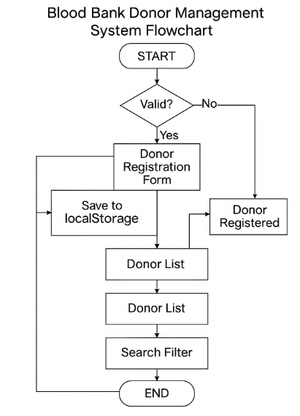

**Fig 2.1 Blood Bank Donor Management System Flow Chart**

Fig 2.1 illustrates the operational workflow of the Blood Bank Donor Management System, with a focus on the donor registration, validation, data storage, and donor search processes. The process begins at the Start node and immediately checks for the validity of user input through the Form Validation step.

If the form input is found invalid—such as missing fields, incorrect formats, or underage donors—the process is halted, and users are prompted to correct their entries. If the input is valid, the flow proceeds to the Donor Registration Form, where data such as name, age, Aadhar number, blood group, mobile number, address, and last donation date are collected.

Once the form is submitted, the system creates a Donor Object and executes a Save to local Storage operation, where the donor's information is securely stored within the browser using the Local Storage API. This ensures persistent data storage without the need for backend databases or internet connectivity.

Upon successful storage, a confirmation is shown as Donor Registered, and the user is redirected to the Donor List interface. Here, the system retrieves and displays all donor records in a structured card layout, allowing users to easily scan through available donors.

The next step allows for Search Filtering, enabling real-time lookups based on donor name or blood group. This feature is particularly useful during emergency medical situations were locating a specific blood group quickly can be life-saving.

The process concludes with the End node, signifying the successful completion of either donor registration or donor retrieval. The structured and user-centric flow promotes efficiency, ease of use, and rapid access to life-critical information, while ensuring data validation, modular design, and future scalability.

### 2.3 INPUT DESIGN

### The Input Design defines the user interface elements that are used to collect data from users. It ensures that inputs are collected accurately and validated before being processed or stored. In the Blood Bank Donor Management System, the inputs are categorized based on the donor registration functionality.

1. **Donor:**

* **Personal Information:**
  + **Donor Name:** Text input for full name of the donor.
  + **Aadhar Number:** Numeric input to uniquely identify the donor (12-digit UID).
  + **Age:** Numeric input with minimum validation (must be 18 years or older).
* **Blood and Contact Details:**
  + **Blood Group:** Drop-down selection containing standard blood group types (A+, A-, B+, B-, AB+, AB-, O+, O-).
  + **Mobile Number:** 10-digit numeric input for contact verification.
  + **Address:** Text area input for entering residential address.
* **Donation Details:**
  + **Last Donated Date:** Date picker input to track donation history and eligibility.

Each input field includes HTML5 validation to prevent submission of incomplete or invalid data. The form only proceeds to data storage upon successful validation of all fields.

### 2.4 OUTPUT DESIGN

### The Output Design focuses on how donor information is displayed and retrieved for end users. Outputs are presented in a structured, searchable format to facilitate quick decision-making, especially in emergencies.

## 1. Donor Registration Confirmation:

## Registration Status:

## A pop-up message ("Donor registered successfully!") confirms successful data entry and storage in the local system.

## 2. Donor List View:

## Card Layout Output:

## Displays key donor details in a clean and organized card format:

## Name

## Age

## Blood Group

## Aadhar Number

## Mobile Number

## Address

## Last Donated Date

## 3. Search and Filter Function:

## Real-Time Output Display:

## On the Donor Management page, users can filter and search donor data dynamically by:

## Blood Group

## Donor Name

## This interface allows for instant access to donor information, facilitating quick retrieval during emergency requirements or when matching a specific blood type is needed. All outputs are rendered from the data stored in the browser's local storage without requiring page reloads or backend interaction.

## 3. SYSTEM DEVELOPMENT

### 3.1 MENU LEVEL DESCRIPTION

###### The Menu Level Description outlines the hierarchical structure of user interfaces and functionalities available in the Blood Bank Donor Management System. The system is designed with simplicity in mind, offering only essential but powerful features accessible through two core interfaces: the Donor Registration Page and the Donor Management Page.

### 1. Donor Registration Menu:

### Homepage (donor.html):

### The landing page for adding new blood donors to the system.

### Provides a structured form to input the following details:

### Name

### Aadhar Number

### Age

### Blood Group

### Mobile Number

### Address

### Last Donated Date

### Upon successful submission and validation, donor data is saved to the browser’s local storage and the user is redirected to the donor management view.

### 2. Donor Management Menu:

### Homepage (index.html):

### Main dashboard for viewing all registered donors.

### Features:

### Displays a card layout for each donor showing detailed personal and donation information.

### Includes a search bar that allows users to search and filter donor records by:

### Donor Name

### Blood Group

### Search Functionality:

### Real-time filtering of the donor list based on partial input (e.g., typing “A+” shows only donors with blood group A+).

### This two-level menu structure ensures clarity, ease of use, and fast access to both registration and search functions—making it suitable for quick deployment in blood donation camps or clinics.

### 3.2 PROCESS SPECIFICATION

Process specification is a critical step in software development used to define, analyze, and document the logic behind how inputs are transformed into outputs. It ensures that each system operation is traceable, verifiable, and maintains consistency. For the Blood Bank Donor Management System, process specification focuses on input validation, data handling, and real-time data rendering through a client-side interface.

**1. Donor Registration Process:**

**Step 1:**  
User accesses the **Donor Registration Page** (donor.html).

**Step 2:**  
User inputs donor details including name, Aadhar number, age, blood group, mobile number, address, and last donation date.

**Step 3:**  
Client-side **validation** checks are performed:

* No field should be left blank.
* Mobile number must be 10 digits.
* Age must be ≥ 18.
* A valid blood group must be selected.

**Step 4:**  
Upon successful validation, a **donor object** is created in JavaScript.

**Step 5:**  
Donor data is **stored in localStorage** using JSON.stringify().

**Step 6:**  
User is redirected to **index.html**, with a confirmation message.

**2. Donor Data Listing and Retrieval:**

**Step 1:**  
On loading the **Donor Management Page**, the system fetches the donor list from localStorage.

**Step 2:**  
Each donor's information is displayed in a **card-based layout**, dynamically generated using JavaScript DOM manipulation.

**Step 3:**  
If no data is found, a placeholder message “No donor data found” is shown.

**3. Search and Filter Functionality:**

**Step 1:**  
User inputs a search term (donor name or blood group) in the search box.

**Step 2:**  
System filters the donor list using case-insensitive string matching.

**Step 3:**  
Filtered results are displayed in real-time without reloading the page.

**4. Data Integrity and User Feedback:**

**Step 1:**  
The system provides **alerts** for invalid submissions (e.g., incomplete fields or incorrect values).

**Step 2:**  
A successful registration triggers an alert saying:  
**"Donor registered successfully!"**

**Step 3:**  
All stored data persists across sessions until the browser cache or localStorage is manually cleared.

**5. System Scalability and Maintenance:**

**Step 1:**  
Although currently designed for standalone operation using client-side technologies, the modular structure allows for easy transition to:

* Backend database integration (e.g., Firebase, MySQL)
* Role-based login system for admins and medical staff

**Step 2:**  
The clean code structure supports future enhancements such as:

* Donor eligibility reminders (based on last donation date)
* PDF report generation
* Cloud-based synchronization

**4. SYSTEM TESTING**

**4.1 SCRREEN LAYOUTS**

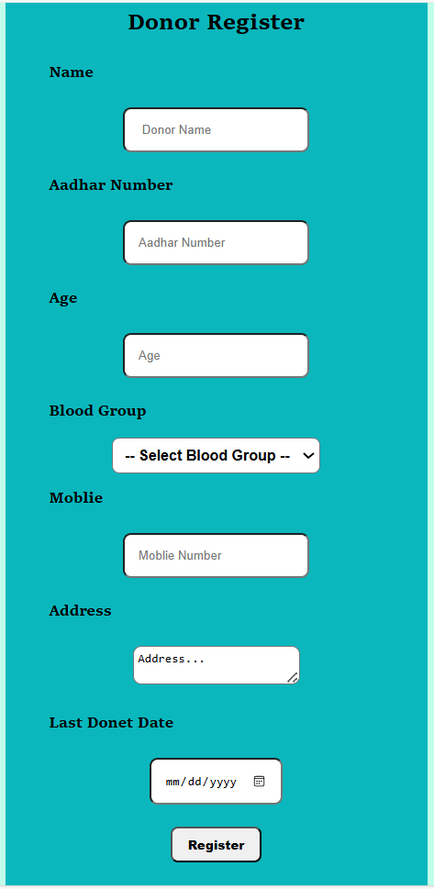

#### Donor Form Interface

#### 

#### Donor Registration Success Alert

#### 

#### Donor Search Functionality

## 5. CONCLUSION

The Blood Bank Donor Management System offers a practical and efficient solution for digitizing and managing critical blood donor information. By automating the process of donor registration, data validation, and retrieval through a simple web-based interface, the system reduces reliance on paper records and minimizes the risks associated with manual data handling.

Its intuitive design and real-time local storage mechanism enable healthcare staff and volunteers to quickly register donors and search for specific blood groups during emergencies. The use of client-side technologies ensures that the system remains lightweight, responsive, and operable even in low-resource or offline environments such as rural clinics or mobile blood donation camps.

The system promotes improved operational readiness by facilitating instant access to donor data, enhancing accuracy, and eliminating redundancy. Furthermore, the modular structure supports easy scalability and future integration with cloud storage, hospital systems, or role-based user access features.

Overall, the Blood Bank Donor Management System proves to be a valuable tool in modernizing blood donation services, supporting timely medical responses, and contributing to life-saving healthcare delivery in both urban and rural settings.

## 6. BIBLIOGRAPHY

1. OpenAI: "GPT-3: Language Models for Text Generation." https://[www.openai.com](http://www.openai.com/)
2. GeeksforGeeks: "Computer Science Portal." [https://www.geeksforgeeks.org](https://www.geeksforgeeks.org/)
3. YouTube: “Various Tutorials and Educational Content." https://[www.youtube.com](http://www.youtube.com/)